PRESS RELEASE

16th JANUARY 2023

LATCHAID, A LEADING BREASTFEEDING & PARENTING SUPPORT APP, REBRANDS TO BECOME ANYA
Now able to help even more parents and support better UK health outcomes for families
LatchAidTM, the ground-breaking app has relaunched its Gen2 app as Anya, to enable them to support parents better. The rebrand allows the app to expand its scope beyond breastfeeding to the first 1,001 days of parenthood, helping families to overcome a much broader range of challenges in line with the UK Government’s A Better Start in Life initiative. The LatchAidTM name lives on as the unique 3D breastfeeding support tool in the app.
Anya is at the forefront of empowering new parents to get immediate access to support and information from trusted sources, reducing anxiety and increasing confidence. The app allows healthcare teams to provide continuity of care, bridging the gap between antenatal and postnatal care to improve health outcomes.
The only parenting app powered by empathy and innovation
The rebrand has been developed to showcase the app as a leading credible, consistent, and cutting-edge parenting app in the marketplace.
The Gen2 app itself has benefitted from a complete redesign and redevelopment for a fresh and sleek new look, much smoother workflow, and user experience, building on user feedback from the Gen1 app launched in August 2021. The LatchAidTM tool has been improved to provide clear visual learning for latching.
The new Anya AI virtual supporter has been built with wider, deeper, and more efficient 24/7 support from AI and from specialists, with users able to access active and historic chats. In other areas, the brand-new Insights and Explore components offer tailored articles, videos, webinars, and content to parents across the whole pregnancy, parenting and infant feeding spectrum. Virtual community groups have been expanded and offer moderated peer support. All information is shared in a caring, non-judgemental, and supportive way.
Levelling up access for all parents to consistent information
The app helps new parents to navigate the minefield of parenting information out there to find credible information and support. With breastfeeding rates in the UK amongst the lowest in the world, and experts saying that 90% of mothers gave up breastfeeding before they wanted to¹, it’s clear there needs to be more support available. The unique LatchAidTM 3D interactive animation tool coaches correct positioning and attachment anytime, anywhere, with the Anya virtual supporter on hand to answer any questions.
Led by Shel Banks IBCLC, the clinical team has created a huge range of new antenatal and postnatal content to answer users’ queries and concerns, and to signpost them to other healthcare help when needed.
Doubling breastfeeding rates where deployed
Having proved that the app can double the average exclusive breastfeeding rate postnatally at 6-8 weeks in an NHS Pilot study with 12 NHS trusts across 4 Integrated Care Systems over 6 months², it’s been an intense period of accelerated development for the team to bring the new app to market, whilst also partnering with a growing number of Integrated Care Systems and NHS Trusts around the country, including HCRG Care Group in Lancashire, Everyone Health in Knowsley, Somerset NHS Foundation Trust, and Dartford and Gravesham NHS Trust in Kent.
Supplementing support from overstretched maternity services
62% of enquiries to the app come in out of office hours, demonstrating that Anya can provide scalable evidence-based support 24/7 where it’s needed. The app is already proving its worth in selected Integrated Care Systems, supporting continuity of care, improved patient outcomes, cost of care reductions and bridges the breastfeeding support inequalities gap. User and healthcare professional feedback also illustrates the high level of satisfaction and recommendation for the app.
Health tech helping to tackle health inequalities
LatchAid Ltd. also recently announced that it had won the coveted SBRI Healthcare funding competition to develop additional features and content in the app to tackle healthcare inequalities in maternity care. This project will be co-developed with key NHS partners, along with groups of parents in target demographics.
The programme will expand the game-changing technology solution to address health inequalities, including more accurate and diverse 3D interactive breastfeeding animations, sentiment AI with a multi-response action system to provide personalised, empathetic support, and virtual peer-to-peer support communities allowing self-selection by ethnicity, language, and other key themes supported by a diverse range of real-life specialists. our PPIE work with questionnaires and interview studies to identify needs, challenges for parents antenatally and postnatally and with the target populations. These informed our R&D work to solve these issues with sharp focus to improve health outcomes for mothers and babies.
By June 2023, the project will aim to have a clear understanding of how the Anya app can best reach and support underserved communities to address inequalities while improving wider breastfeeding rates and other health outcomes. A wealth of tailored articles, videos, webinars, drop-ins aimed at the target populations of families of colour, low-income families, and young parents. Dr. Chen Mao Davies, Founder and CEO of LatchAid, commented, “It’s been so exciting to see my baby LatchAid grow up into Anya, on both iOS and Android. We know how important access to evidence-based information and support has already been to new parents via the app. We look forward to reaching many more families inclusively with our SBRI Healthcare funding.”

ENDS

¹ Anya by LatchAid NHS Pilot Outcomes, rate of breastfeeding at 6 wks vs. England ave., 271 respondents
² NHS England Maternity Services Review, 2016

NOTES FOR EDITORS
Information about the new Anya app
For expectant & new parents, the Anya app is the best tool to support you through your early parenthood & breastfeeding journey. Using LatchAidTM 3D interactive animations, Anya virtual supporter, real-life experts, & a close-knit community, we’re here to support you with credible & expert guidance every step of the way.
Anya and the LatchAidTM tools were developed by specialists who work with parents every day to help them reach their parenting & breastfeeding goals. Many mothers of new-born babies give up breastfeeding less than three months after birth, due to physical pain, frustration & anxiety. We are here to help support you with empathy & companionship.
We believe that every parent deserves the support & empowerment to give their child the best start in life. Together we nurture.
Dr. Chen Mao Davies developed the LatchAid tool with collaborators from her Oscar and BAFTA award-winning career in blockbuster films, such as Blade Runner 2049 and Gravity. After struggling with breastfeeding and postnatal depression with her first child, she decided when her second child Anya was born that she would develop an app that could support parents everywhere, 24/7.
Gen2.0 app features:
- Anya AI virtual supporter: #AskAnya anytime, anywhere
- 1-to-1 support from Specialists behind the scenes
- LatchAidTM 3D breastfeeding tool to help parents feed successfully
- Virtual peer support communities
- Evidence-based pregnancy, parenting & breastfeeding/chestfeeding resources built by specialists, including articles, webinars, videos, FAQs.
- Tailored content in our brand new Explore section.
Awards:
- Winner of SBRI Healthcare Health Inequalities in Maternity Care Phase 1 competition
- Shortlisted for NHS Innovation Accelerator Fellowship programme 2023
- Innovate UK Women in Innovation Award winner
- Winner of 4 Innovate UK funding competitions
- Q exchange award from NHS improvement and The Health Foundation
- Top 100 Asians in UK Tech – Top 5 UK Startup 2022
- MSDUK innovation challenge – health & wellbeing category winner
- No.22 in Health Tech World’s Top 50 Global Innovators
- Business Insider 42 under 42 – South West 2021.

For more information, further images, and requests for interviews, please contact:
Annabel Wallis, Head of Marketing
+44 7796 691069 annabel.wallis@latchaid.com

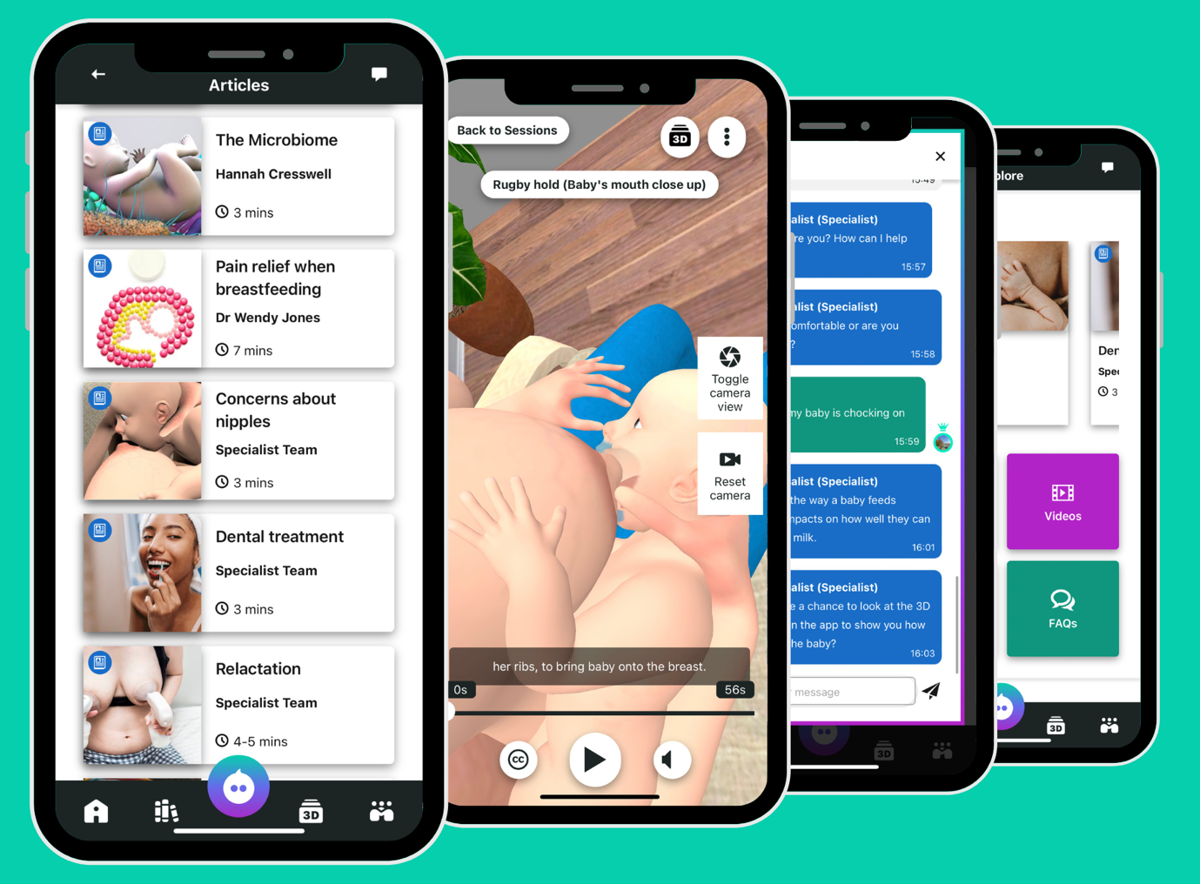
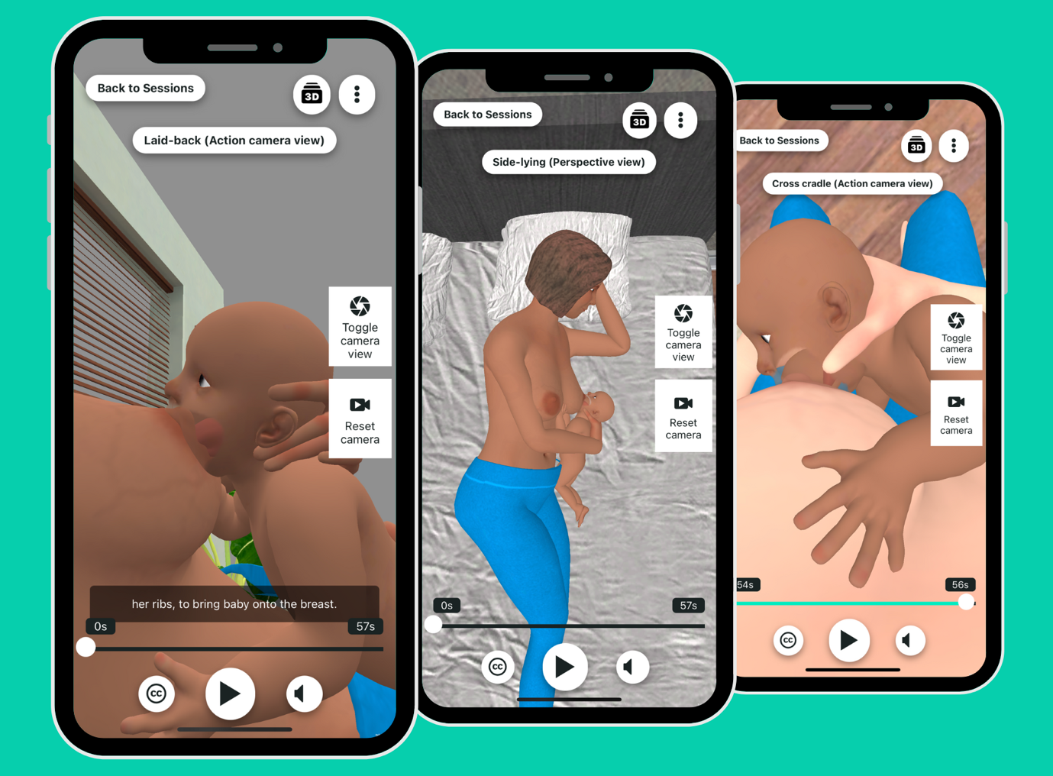
anya.health

